### Trimester

### First Trimester

Physical and Emotional Changes a Woman May Experience

* Extreme fatigue
* Nausea with or without throwing up (morning sickness)
* Cravings or aversion to certain foods
* Mood swings
* Constipation
* Frequent urination
* Headache
* Heartburn
* Weight gain or loss

### Second Trimester

### Third Trimester

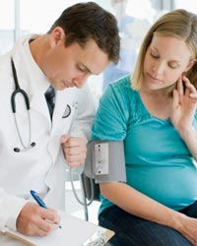MEDICAL TEST:

* Fetal Heart Rate Monitoring
* Group B streptococcus
* Glucose Tolerance Test
* Multiple Marker Screening
* Fetal Ultrasound
* Blood Pressure
* Urine Tests
* Rh Factor Test
* Sexually Transmitted Diseases
* Complete Blood Count

FOOD AND NUTRIENTS



PHYSICAL AND EMOTIONAL CHANGES:

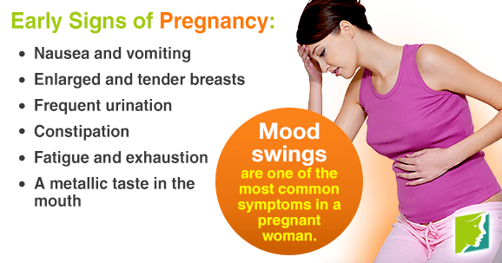

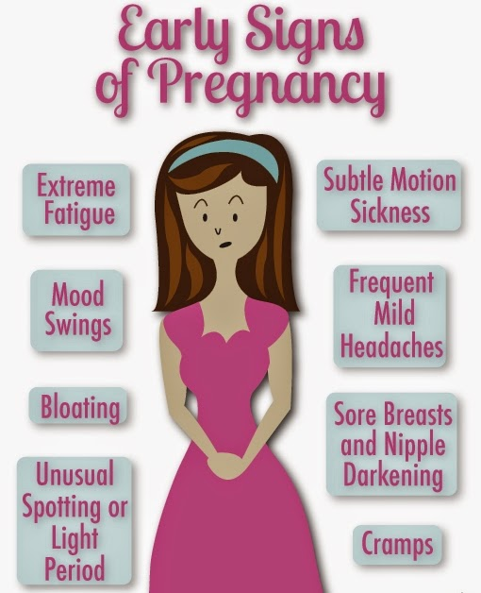

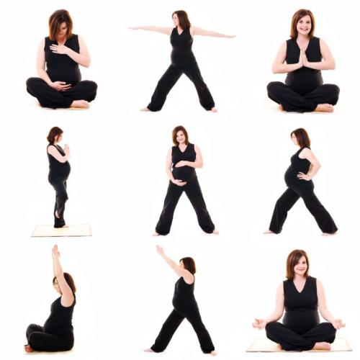EXERCISE:

